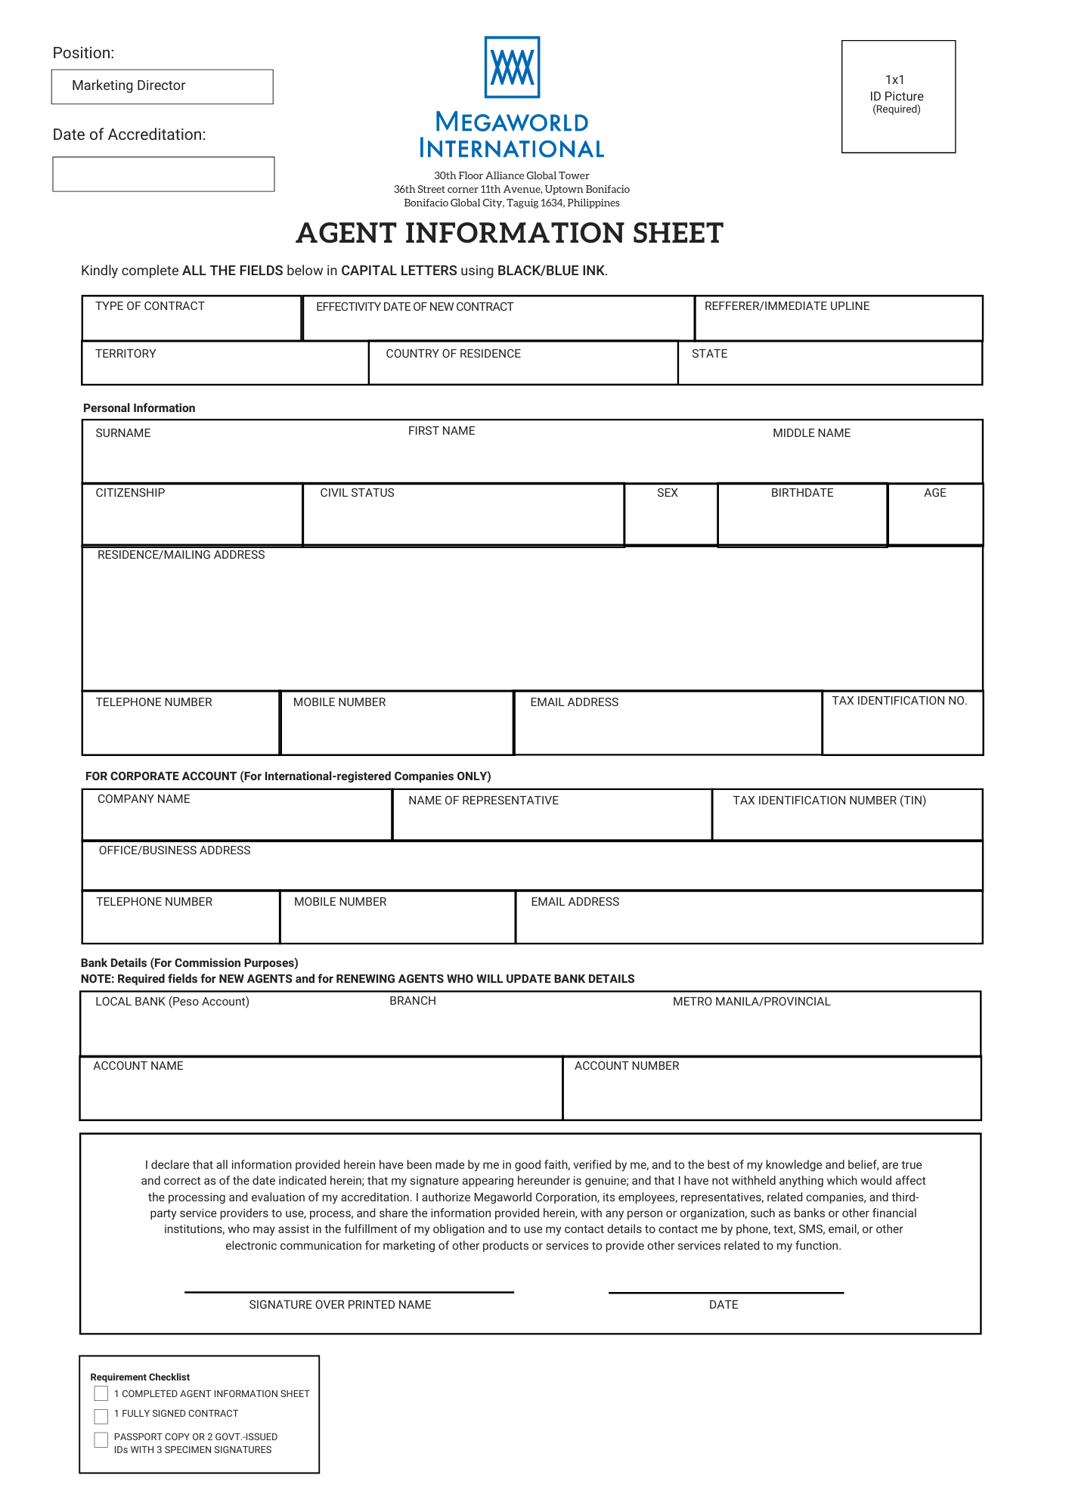

{{format_date ADate “MMMM DD, YYYY”}}
{{insert_image photo 96 96}}
{{contract}}
{{countrymanager}}
{{surname}}
{{firstname}}
{{middlename}}
{{address}}
{{telephone}}
{{corpname}}
{{corprepresentative}}
{{corptin}}
{{corpaddress}}
{{corptelephone}}
{{corpmobile}}
{{corpemail}}
Business Development Group
{{format_date _date “MMMM DD, YYYY”}}

{{format_date ADate “MMMM DD, YYYY”}} – {{format_date ADate “MMMM DD, YYYY” “en” “+4months”}}

{{country}}
{{state}}
{{territory}}

{{citizenship}}
{{birthday}}

{{sex}}
{{civilstatus}}
{{age}}

{{mobile}}
{{tin}}
{{email}}

{{localbank}}

{{bankacctnumber}}
{{bankacctname}}

{{insert_image signature 200 70}}

{{firstname}} {{middlename}} {{surname}}
{{format_date ADate “MMMM DD, YYYY”}}



MARKETING AGREEMENT
Marketing Director (MD)
{{format_date ADate “MMMM DD, YYYY”}}
This Agreement was made and executed on __________________ at Taguig City, Metro Manila, Philippines, by and between:

MEGAWORLD CORPORATION,
a corporation duly organized and existing under Philippine laws, with offices
at the Megaworld International 30th F, Alliance Global Tower, 36th Street cor.
11th Avenue, Uptown Bonifacio, Taguig City 1634, represented herein by
{{territoryhead}} - {{territory}}

____________________________________________________________
(hereinafter referred to as “Megaworld”)

-and-
{{firstname}} {{middlename}} {{surname}}
_______________________________________________________________,
{{citizenship}}
_______________________ citizen of legal age, with residence address at
{{address}}
________________________________________________________________
(hereinafter referred to as “Marketing Director”)
{{insert_image signature 200 70}}

WITNESSETH: That –

WHEREAS, Megaworld and its affiliates (the “Megaworld Group”) are engaged in the business of developing, marketing, and leasing of real estate properties located in the Philippines;

WHEREAS, Marketing Director is an independent contractor and has offered to Megaworld their services for the marketing and sale of units in certain real estate projects of the Megaworld Group;

WHEREAS, Megaworld is willing to accept such offer under the terms and conditions stated below;

NOW, THEREFORE, for and in consideration of the foregoing premises and the conditions and stipulations hereinafter set forth, the parties hereto mutually agree as follows:

- Obligations of Marketing Director
Marketing Director shall perform and comply with the following obligations:

  - To promote and sell units in the real estate projects (the “Projects”) of the Megaworld Group specified in Annex “A” or as may be advised by Megaworld from time to time, at such prices, terms and conditions as may be prescribed by Megaworld. Marketing Director is not authorized to give discounts, special rebates, or concessions of any kind in favor of any person without the express written consent and authority of Megaworld.


  - To recruit, train, manage and motivate its Marketing Network composed of Marketing Managers and Marketing Associates.

  - The Marketing Director is not allowed to receive any payments from buyers of units in any of the Projects but shall instead cause the immediate remittance to the account of Megaworld of any and all payments of buyers of units in any of the Projects by way of telegraphic remittance. In case the telegraphic remittance of payments if is not possible or feasible, the Marketing Director shall be authorized to receive payments from buyers but only in the form of crossed check(s) payable to Megaworld or its designated nominee.

  - Payments should be deposited by the client directly to the account as specified in Annex D. Please be reminded that the agents are not authorized to receive cash payment from the clients.

  - To comply with the Sales and Marketing Network Requirement determined by Megaworld and specified in Annex “B”.

{{insert_image signature 200 70}}

  - To maintain the necessary business organizations, facilities, and services to enable it to properly perform the marketing and sales functions contemplated under this Agreement, including but not limited to setting up and maintaining the appropriate office space and communication facilities. To assign at least one staff to oversee day-to-day operations.

  - To be professional in all its dealings and transactions with clients.

  - To act strictly in accordance with the authority granted to it under this Agreement. Any act of misrepresentation committed by the Marketing Director or any of its agents shall not bind Megaworld but shall be the sole liability and responsibility of the Marketing Director.

  - To comply strictly with all directives, instructions, procedures, guidelines, circulars etc., which Megaworld may, from time to time, issue to the Marketing Director in relation to the performance of its duties under this agreement.

- Obligations of Megaworld
Megaworld shall perform the following obligations:

  - To pay Marketing Director Commissions for all sales of units in the Projects initiated and consummated by him/her at the rates specified in Annex “B” and in accordance with the schedule for release of commissions to be agreed upon between the parties specified in Annex “C”, (the “Schedule”).

  - To supply the Marketing Director by way of distribution of sales materials, such as brochures, leaflets, price lists, business cards, pamphlet/fliers, etc.; necessary for the discharge by the Marketing Director of its obligations under this Agreement.

- Unconsummated Sales
In case any sale is not consummated for any reason whatsoever, including but not limited to the pre-termination of this Agreement as provided in Section 6, Marketing Director shall no longer be entitled to the commissions corresponding to the uncompleted stage(s) of the sale as reflected in Annex C – Commission Release Schedule.

A sale is not consummated if any or all of the stages of sale as reflected in Annex B Schedule is not accomplished or completed during the effectivity of this Agreement.

- Term
Unless sooner terminated by Megaworld for any of the causes stipulated in Section 6, this Agreement shall be effective for a period of four (4) months from execution of this Agreement (_________________to ______________). This Agreement shall be renewable, at the sole option of Megaworld, for such term as may be agreed upon by the parties.
{{format_date ADate “MMMM DD, YYYY”}} – {{format_date ADate “MMMM DD, YYYY” “en” “+4months”}}
{{insert_image signature 200 70}}

- Exclusivity
For the duration of this Agreement, the Marketing Director shall not promote, sell, or otherwise deal with, for his/her own account, whether directly or indirectly, or for the account of other persons or entities, real estate projects being developed, owned, or otherwise dealt with by other companies, corporations, partnerships or such other entities engaged in a business or industry in competition with Megaworld in the Philippines.

The Marketing Director acknowledges that this Agreement does not preclude Megaworld from promoting or selling, or otherwise dealing with the Projects within the Territory, for its own account or for the account of other persons or entities.

- Pre-termination
Prior to the expiration of the term of this Agreement, Megaworld shall be entitled to terminate this Agreement, upon written notice to Marketing Director, for any of the following causes:

  - Breach or an attempt to breach, by Marketing Director of any of the terms and conditions of this Agreement;

  - Fraud and/or any misrepresentation committed by Marketing Director for the purpose of obtaining the consent of Megaworld in entering into this Agreement;

  - Any change in the government policy and/or laws of the Territory or the Philippines which will render unlawful the performance by Megaworld of its obligations under this Agreement.

- Obligations upon Termination
Within ten (10) days from expiration of the term of this Agreement or from receipt by Marketing Director of a written notice of the termination of this Agreement pursuant to Section 6, the Marketing Director shall be obliged to:

  - Endorse and submit to Megaworld all accounts and/or records of buyers, regardless of the status of said accounts.

  - Turn over to Megaworld all marketing materials, brochures, pamphlets, fliers, etc. supplied to Marketing Director by Megaworld;

  - Settle all outstanding accounts with Megaworld.

- No Employer-Employee Relationship
The Marketing Director is an independent service contractor, which shall do business in his/her own name and for his/her own account and shall not incur any liability on behalf of Megaworld. Nothing contained in this Agreement shall be deemed or interpreted to constitute Marketing Manager as a partner, agent, or employee of Megaworld.

- Governing Law
This Agreement shall be construed in accordance with and governed by the laws of the Republic of the Philippines.

- Venue of Actions
{{insert_image signature 200 70}}
In case of litigation arising from this Agreement, the parties agree that the proper court of Makati City, Philippines shall be the proper venue of all actions to the exclusion of other courts.

- Amendments
Without prejudice to the directives, instructions, procedures, guidelines, circulars, etc. which may be issued by Megaworld pursuant to Section 1.6, there are no other agreements or understandings between the parties relating to the subject matter of this Agreement. This Agreement supersedes all prior agreements, oral or written, between the parties and is intended as a complete and exclusive statement of the agreement between the parties. No change or modification of this Agreement shall be valid unless the same be in writing and signed by the parties.

- Confidentiality. You acknowledge that, in the course of your services under this Agreement, you may be allowed to access to an/or be in possession of Confidential Information of the Company. Accordingly, you expressly agree that such access or possession of Confidential Information is allowed exclusively for the limited purpose of performing your duties and functions. You undertake not to divulge or use such Confidential Information, in any manner, outside of the above-enumerated duties and functions in this Agreement. In case of violation or threatened violation of this clause, you expressly agree that the Company is entitled to immediately terminate this Agreement and/or secure an injunction against you and/or your violation of this provision, in addition to securing payment of such actual damages as the Company may have suffered or incurred.

IN WITNESS WHEREOF, the parties have hereunto set their hands
{{format_date ADate “MMMM DD, YYYY”}}
is ______ day of _______________________ at ________________________.

{{insert_image signature 200 70}}

MEGAWORLD CORPORATION
{{territoryhead}}
{{firstname}} {{middlename}} {{surname}}
___________________________________ ___________________________________
Signature over Printed Name (Signature over Printed Name)
Territory Head Marketing Director

Witnessed by:

{{seniorcountrymanager}}
{{asst.countrymanager}}

___________________________________ ___________________________________
(Signature over Printed Name) (Signature over Printed Name)
Sr. Country Manager Asst. Country Manager

{{vicepresident}}
{{countrymanager}}
___________________________________ ___________________________________
(Signature over Printed Name) (Signature over Printed Name)
Asst. Vice President/Vice President Country Manager

JAVIER ROMEO K. ABUSTAN
_________________________________
Managing Director

SIGNED IN THE PRESENCE OF:

_________________________________ _______________________________
REPUBLIC OF THE PHILIPPINES (_________________________) S.S.

BEFORE ME, a Notary Public for and in the City of ______ this ___ day of _____________, personally appeared the following:

Name Comm. Tax Cert. No./ Passport No. Date/Place Issued

{{territoryhead}}
________________________
in his/her capacity as
Vice-President for Sales

Name Comm. Tax Cert. No./ Passport No. Date/Place Issued
{{firstname}} {{middlename}} {{surname}}

________________________
in his/her capacity as
Marketing Director

who are known to me and to me known to be the persons who executed the foregoing Marketing Agreement and they acknowledged to me that the same is their free and voluntary act and deed and that of the corporation which is represented therein.
{{insert_image signature 200 70}}

NOTARY PUBLIC

Doc. No. _____;
Page No. _____;
Book No. _____;
Series of 2019


Annex E
Code of Ethics

The Code of Ethics serves as our guide in our working relationship with our business partners: Megaworld VP-Sales, AVP, Senior Country Managers, Country Managers, Assistant Country Managers, Marketing Partners, Marketing Managers, and Marketing Associates.

We agree to support Megaworld International's sales policies, programs, regulations and procedures as our guide in the professional conduct of our business.

We will properly inform our respective network of marketing agents about the Company's policies, programs, regulations and procedures to protect their rights and privileges as business partners.

We will encourage our marketing agents to strive for promotion to higher levels of position in the Company for personal and professional growth and development.

We will respect the marketing network of our fellow marketing agents by:

- Not recruiting marketing agents from other groups to join one's own group in Megaworld International, and/or one's group in other real estate companies or any direct selling company;
- Not selling to marketing agents from other groups;
- Encouraging dissatisfied marketing agents from other groups to settle their differences with their current superiors to avoid transfer of sponsorship.

We will refrain from conducting other real estate marketing business within Megaworld International's premises and/or during Company-sponsored activities. Likewise, we will refrain from using Company resources for other real estate marketing businesses or any other business.

We shall not engage in selling products directly or indirectly competing with Megaworld International.

Together, we agree to police our respective marketing network to protect the rights and privileges of our fellow marketing agents.

Megaworld International reserves the right to disqualify and/or terminate any Marketing agent (VP-Sales, AVP, Senior Country Managers, Country Managers, Assistant Country Managers, Marketing Partners, Marketing Managers, Marketing Associates/Sr. Marketing Associates) from doing business with the company for failure to comply with these policies and for other reasons whatsoever that will prejudice the company's operations as a whole.
{{insert_image signature 200 70}}

{{firstname}} {{middlename}} {{surname}}

___________________________
(Signature over printed name)
Marketing Director

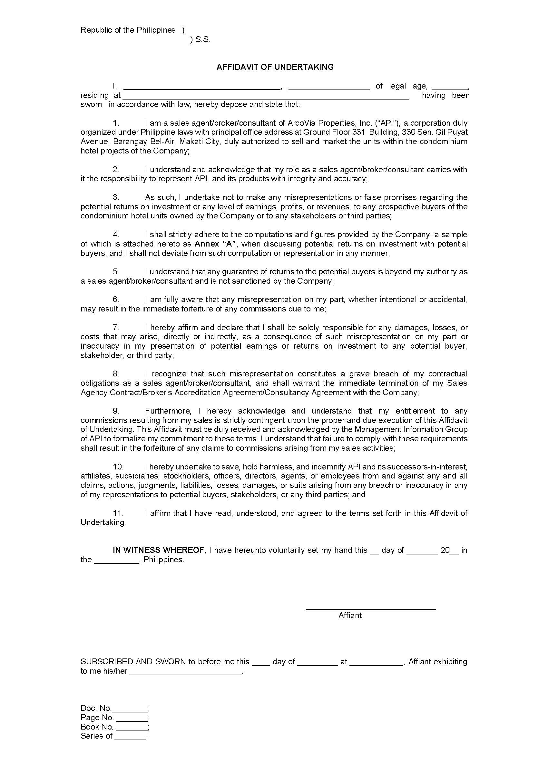
{{age}}
{{citizenship}}
{{firstname}} {{middlename}} {{surname}}
{{address}}

Annex “A”

{{insert_image signature 200 70}}

{{firstname}} {{middlename}} {{surname}}

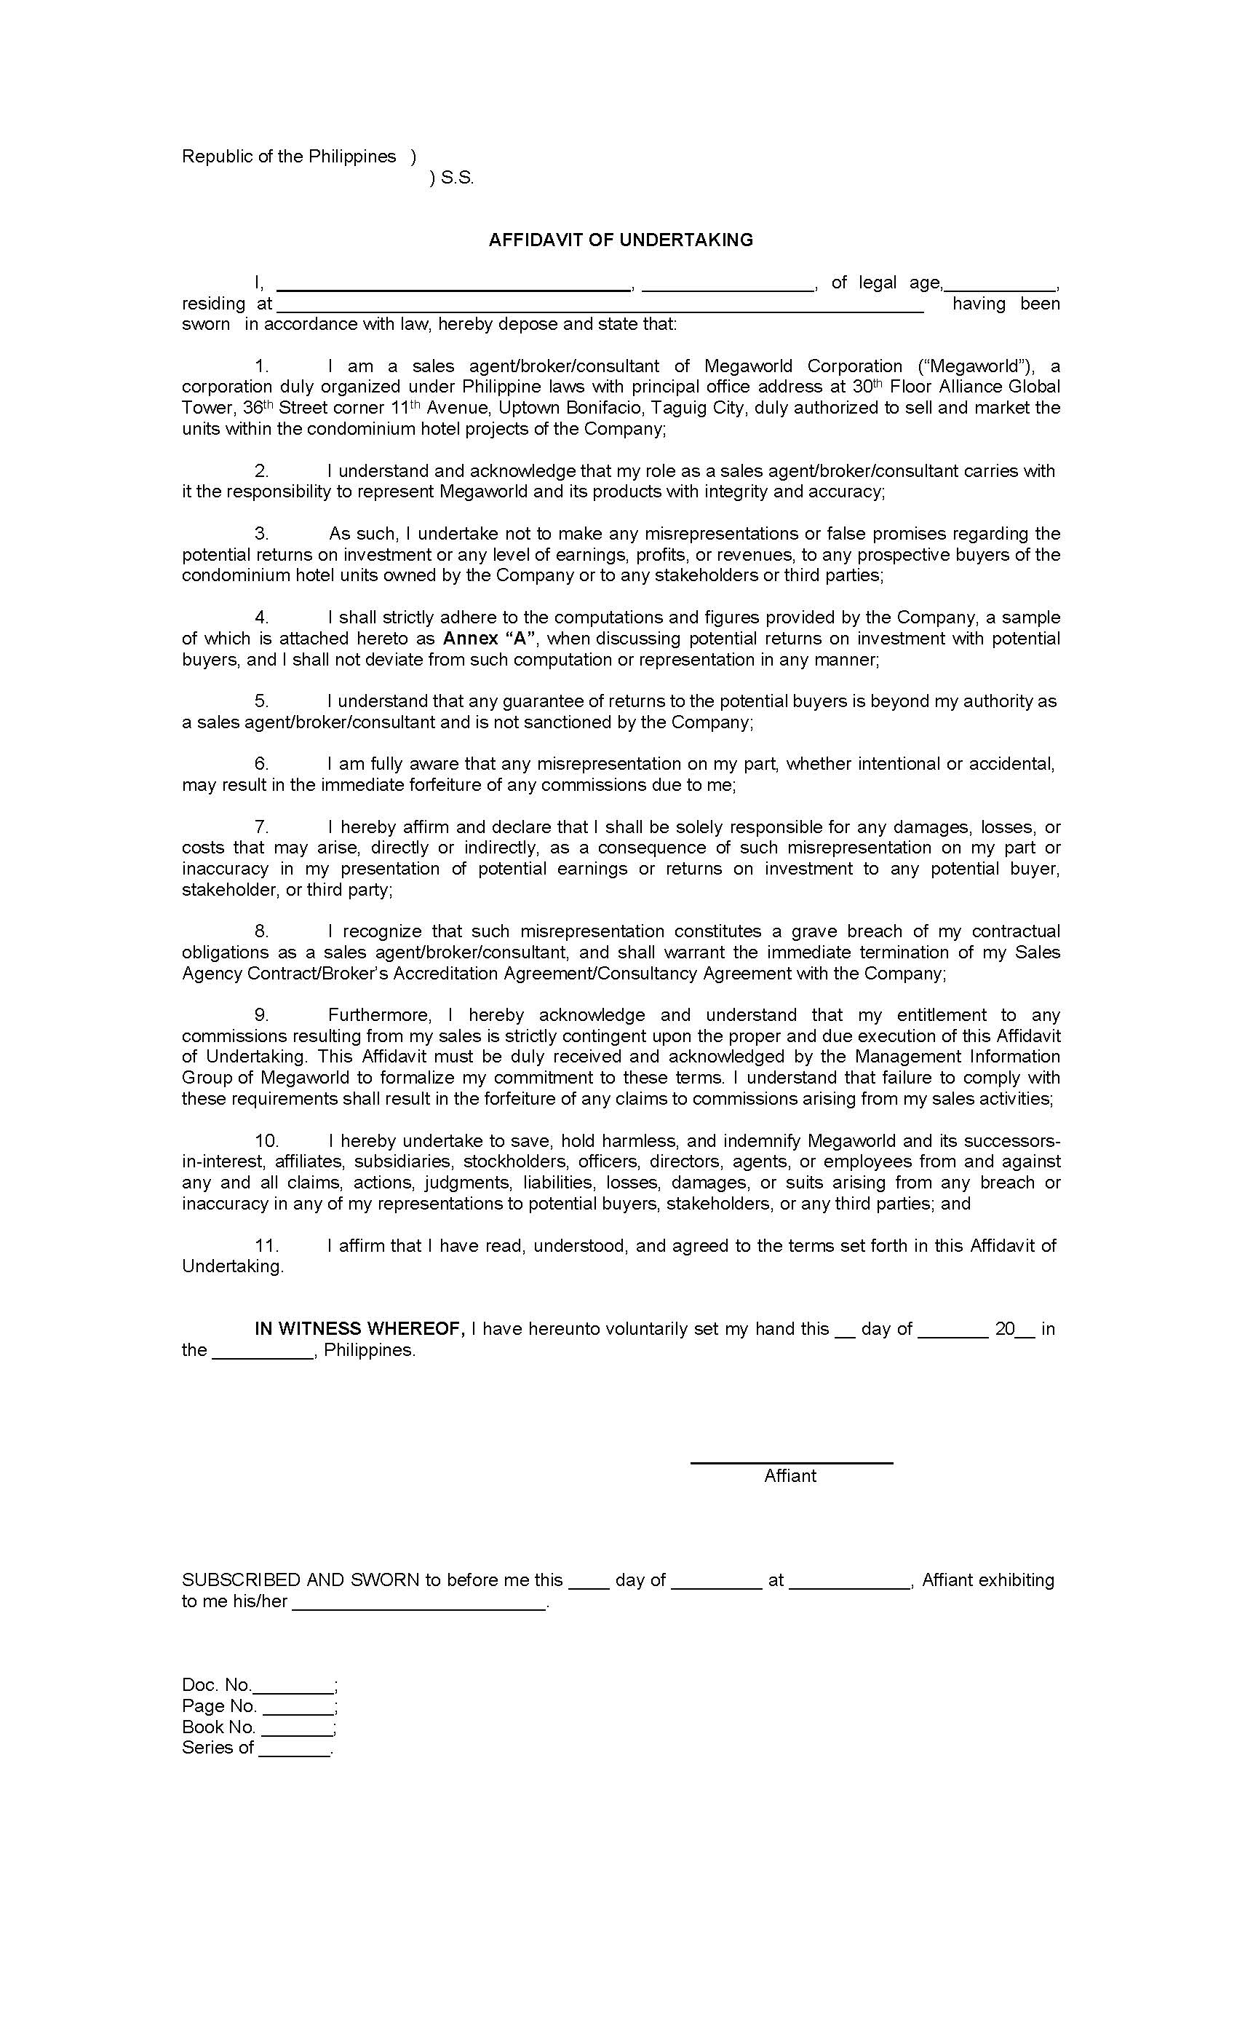
{{age}}
{{citizenship}}
{{firstname}} {{middlename}} {{surname}}
{{address}}

Annex “A”

{{insert_image signature 200 70}}
{{firstname}} {{middlename}} {{surname}}

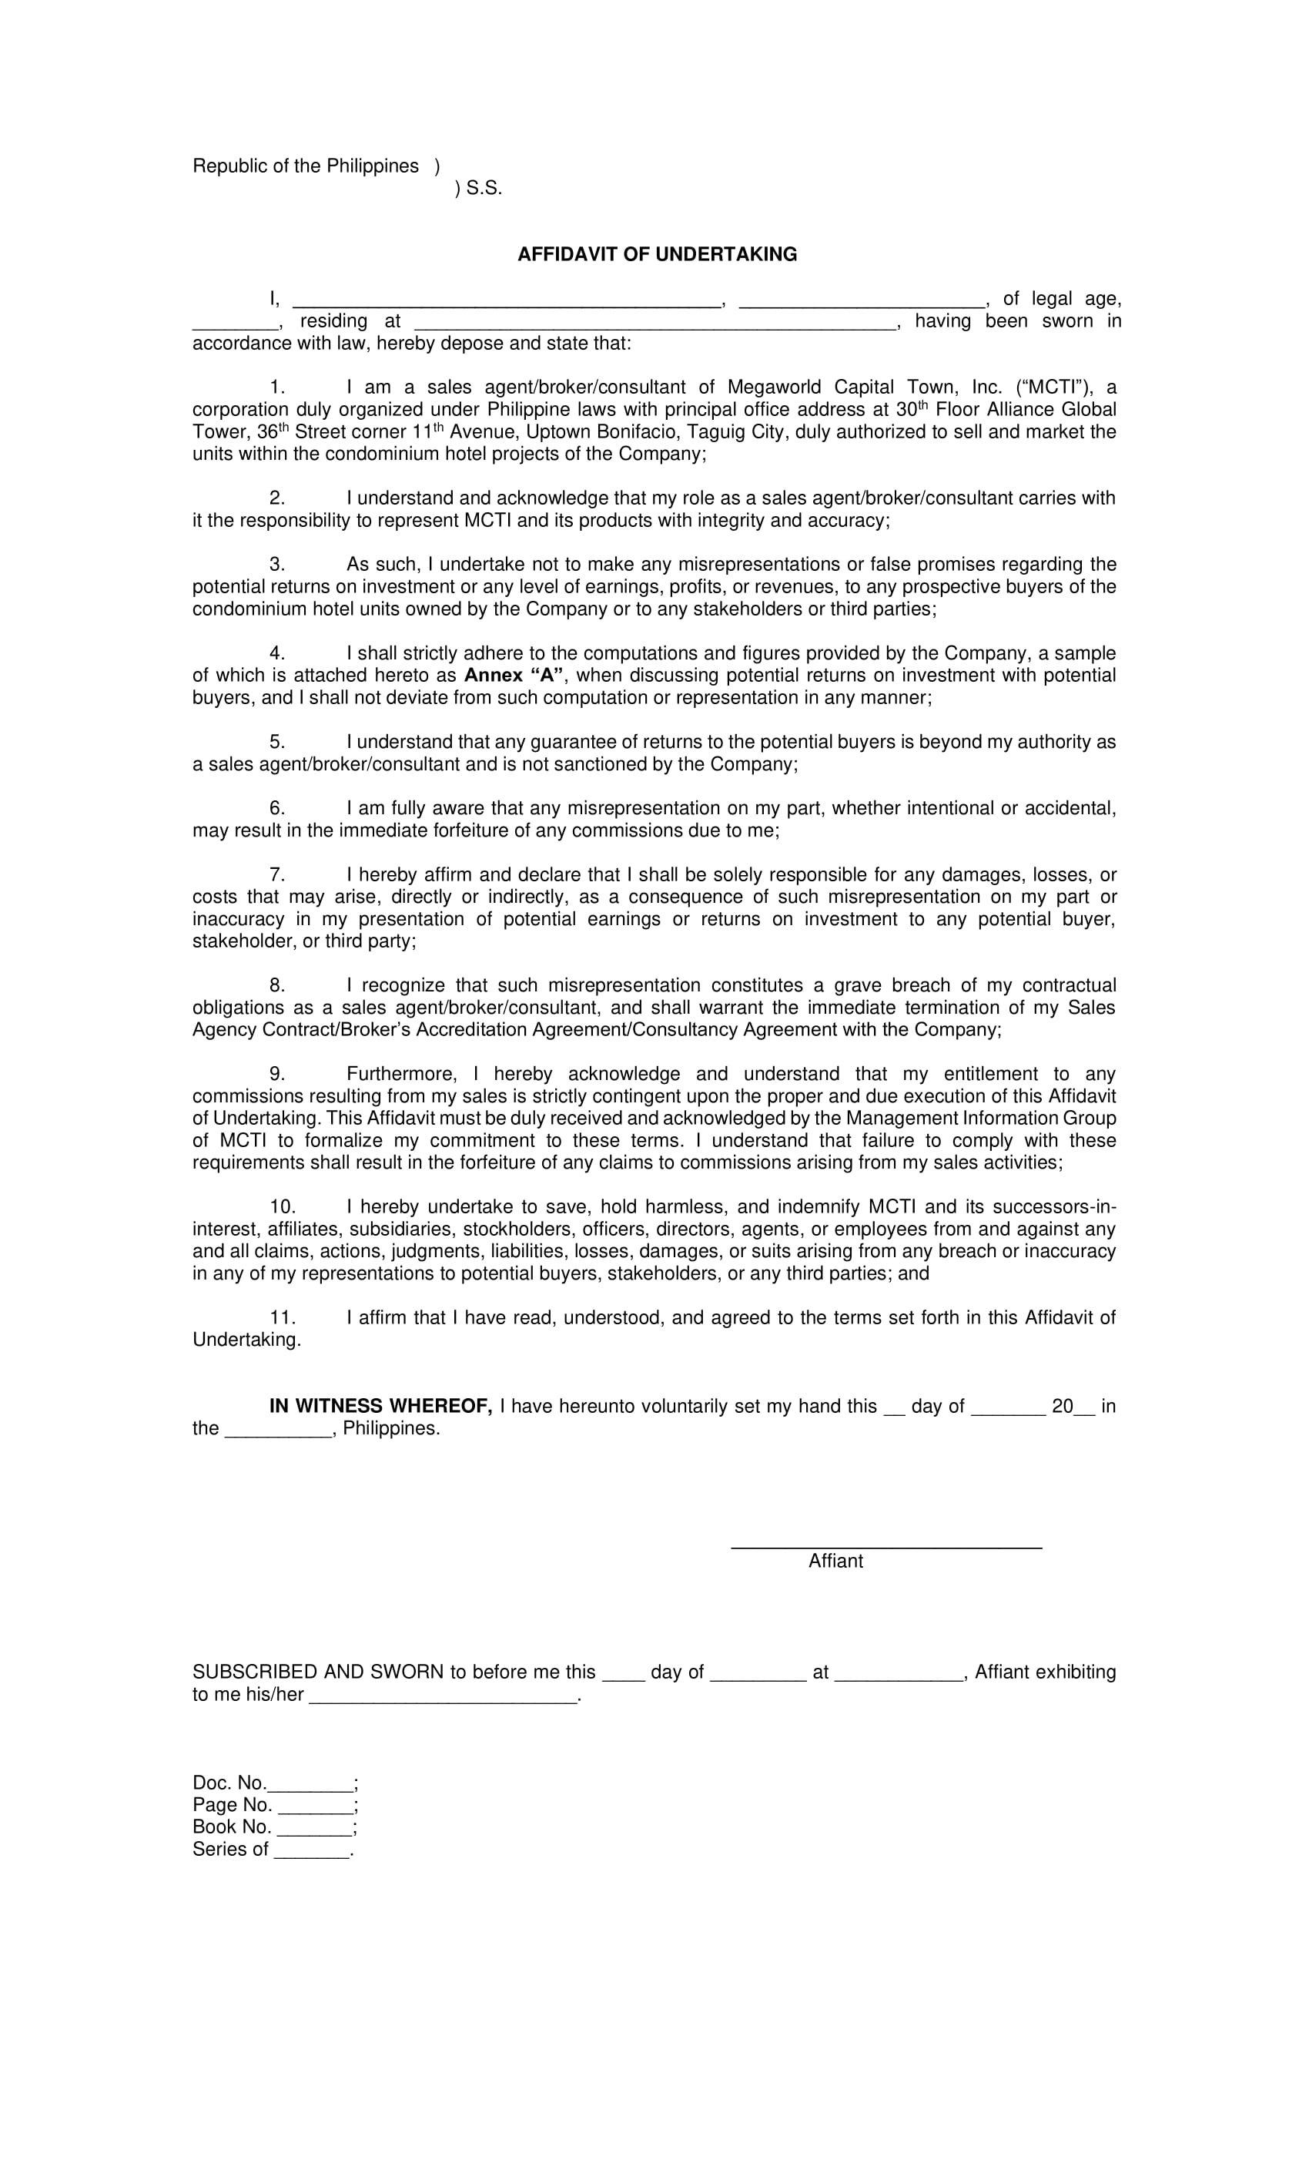

{{address}}
{{age}}
{{citizenship}}
{{firstname}} {{middlename}} {{surname}}

Annex “A”

Annex “A”

{{insert_image signature 200 70}}

{{firstname}} {{middlename}} {{surname}}

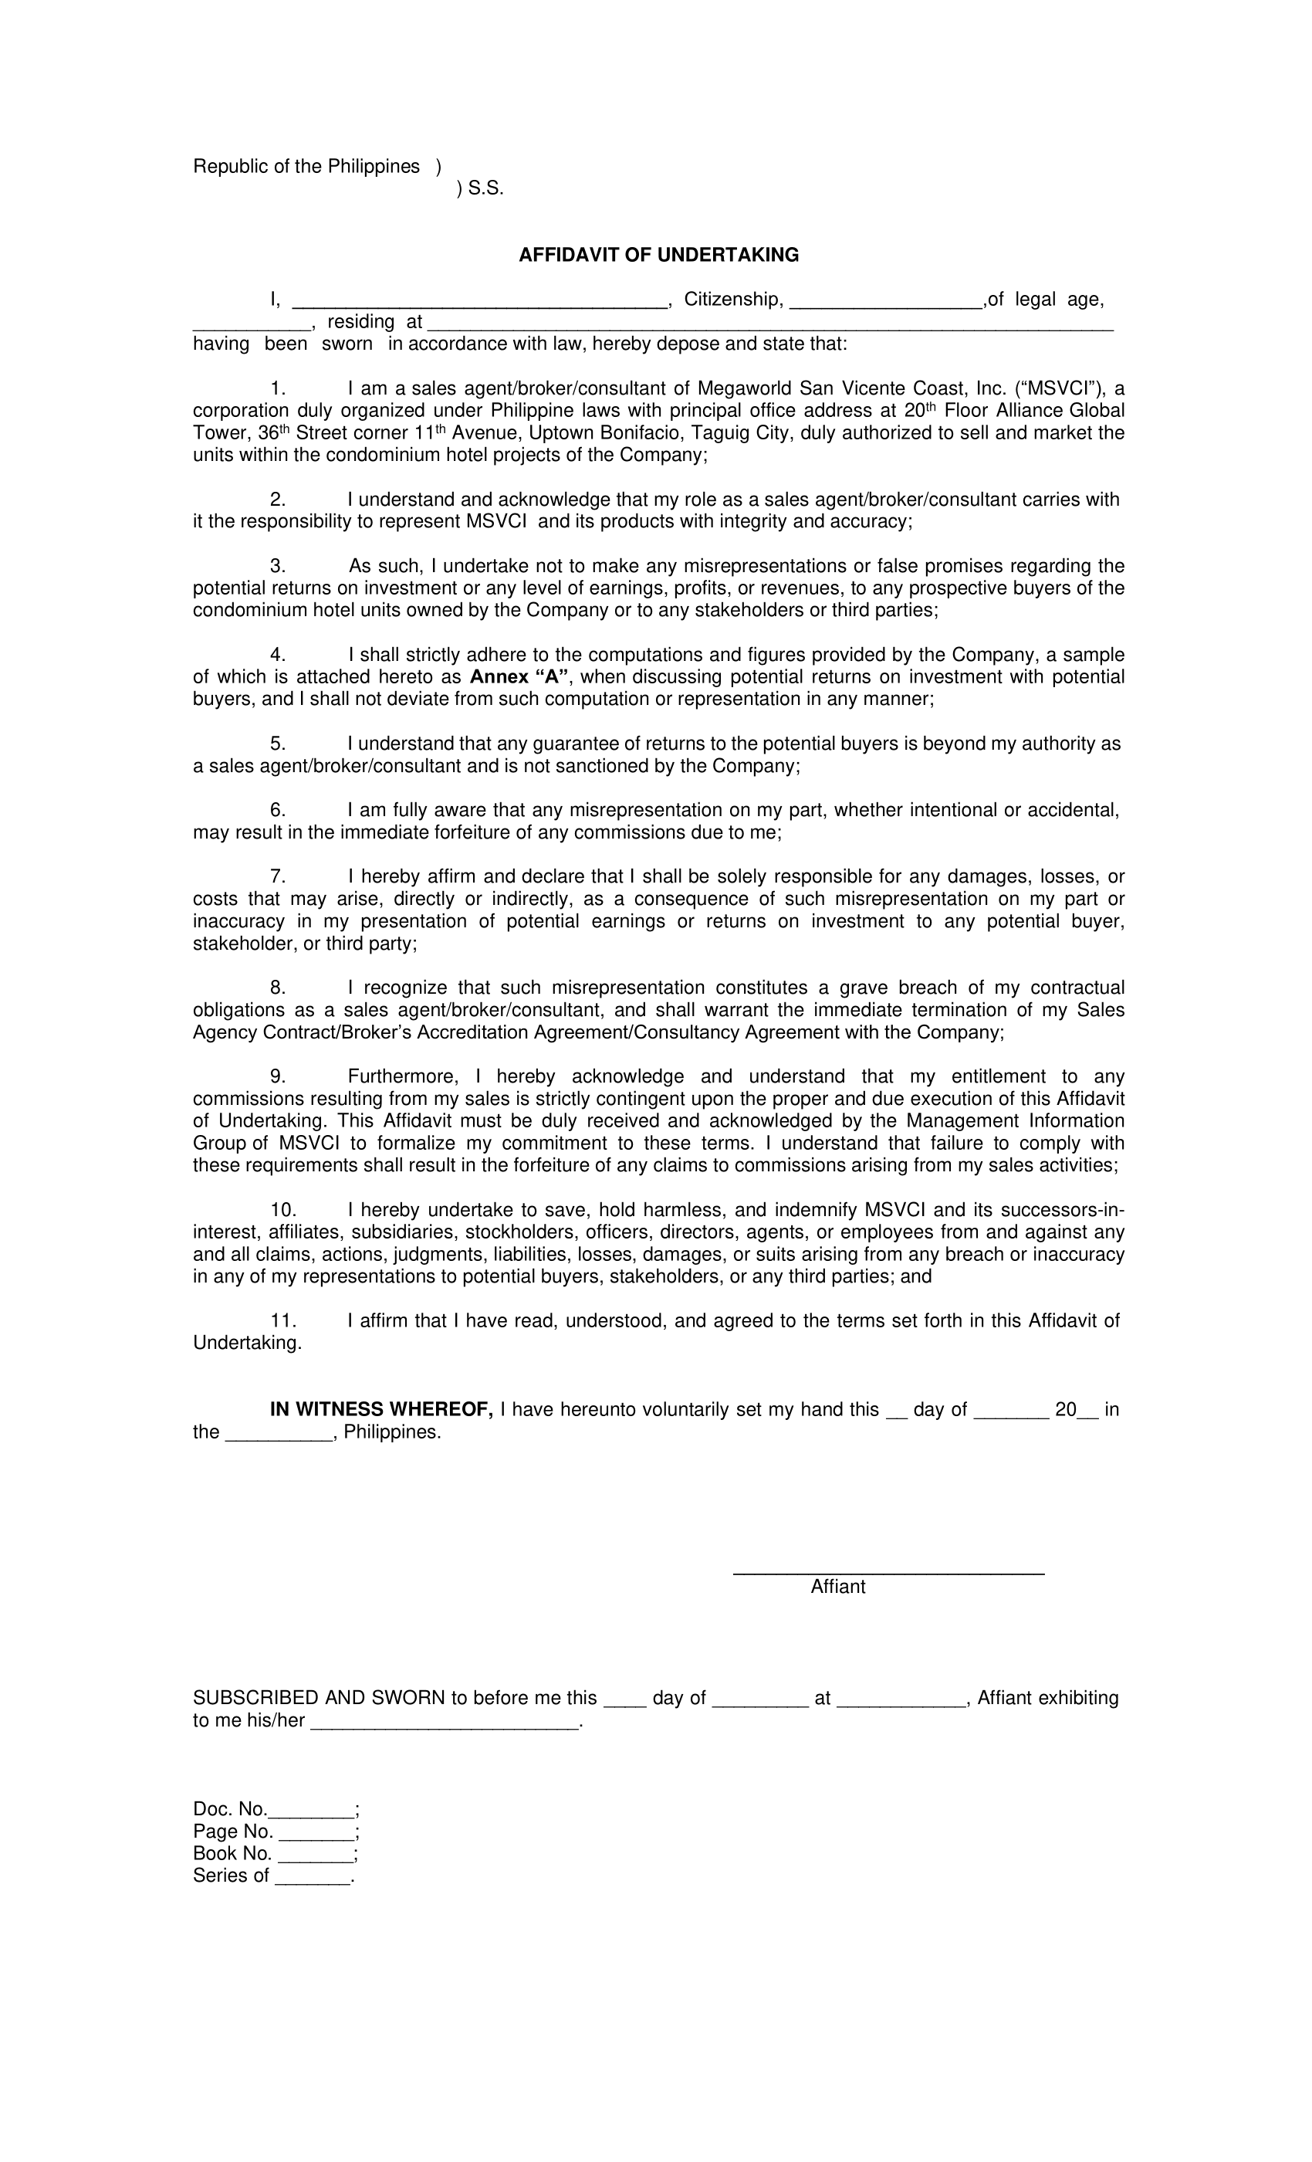
{{firstname}} {{middlename}} {{surname}}
{{citizenship}}
{{address}}
{{age}}

Annex “A”

{{insert_image signature 200 70}}

{{firstname}} {{middlename}} {{surname}}

{{insert_image signature 200 70}}
{{insert_image signature 200 70}}
{{insert_image signature 200 70}}

{{insert_image ID2 192 288}}

{{insert_image passport 384 768}}

